**Xpath Basic**

Xpath=//tagname[@attribute='value']

Login to : https://www.phptravels.net/admin-portal/admin

User/PW: [admin@phptravels.com/demoadmin](mailto:admin@phptravels.com/demoadmin)

Capture 2 elements for each control (Anywhere on Web application):

1. Checkbox:

//tr[1]//input[@class='checkboxcls']

//tr[5]//input[@class='checkboxcls']

1. Menu

//a[contains(text(),'Accounts')]

//a[contains(text(),'Add New')]

1. Button

//button[@class='btn btn-success']

//button[contains(text(),'Last 90 Days')]

1. Label

//div[contains(text(),'Recent Bookings')]

//tr[1]//td[contains(text(),"Hotel")]

5.Textbox

//div[@class='col-md-4']//div[contains(@class,'form-group')]//input[@placeholder='Page Title']

//input[@placeholder='Permalink']

1. Link

//a[contains(text(),'OASIS CANCUN')]

//a[contains(text(),'Alzer Hotel Istanbul')]

1. Image

//tr[1]//td[4]//img

//tr[12]//td[4]//img

1. Icon

//tr[1]//td[12]//span[1]//a[1]//i[1]

//tr[10]//td[12]//span[1]//a[1]//i[1]

1. Tab

//li[@id='account']//a[contains(text(),'Account')]

//strong[contains(text(),'Logout')]

1. Dropdown

//select[@name='default_lang']//option[text()='Turkish']

//select[@name='default_lang']//option[@value='fr']

1. Table

//table[@class='xcrud-list table table-striped table-hover']

//table[@class='xcrud-list table table-striped table-hover']

**Xpath Advance**

1. **Button**

Capture ‘Website’, ‘Delete Selected’, ‘Search’ and ‘Reset Chart’ button

Website: //button[contains(text(),'Website')]

Delete Selected: //a[@class='delete_button btn btn-danger btn-xs']

Search: //*[text()='Search']

Reset Chart: //*[text()=' Reset Chart ']

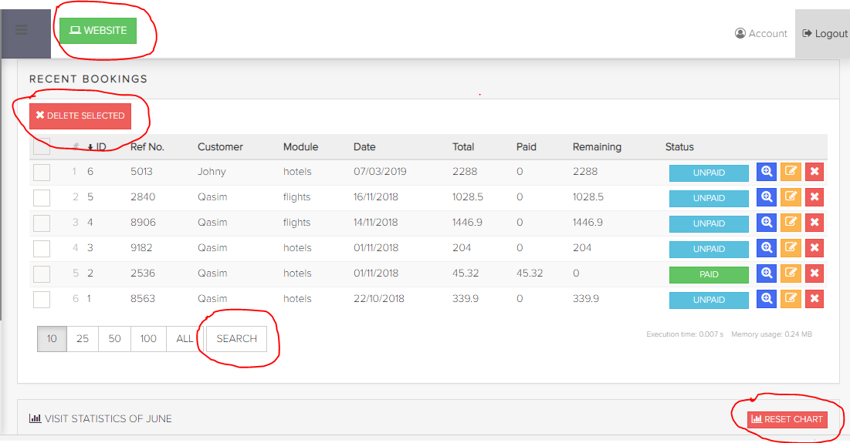

1. **Menu bar**

Capture ‘HOTELS’ Main menu; ‘HOTELS’, ‘EXTRAS’, ‘REVIEW’ sub menu

‘HOTELS’ //*[@id="social-sidebar-menu"]/li[7]/a

‘HOTELS’ //*[@id="Hotels"]/li[1]/a

‘EXTRAS’ //*[@id="Hotels"]/li[3]/a

‘REVIEW’ //*[@id="Hotels"]/li[4]/a

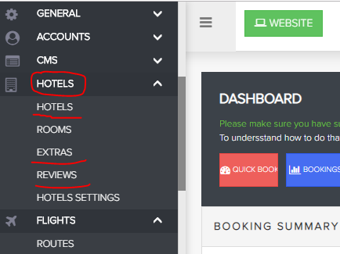

1. **Menu Item**

Capture Main menu that has 6 menu items => ‘FLIGHTS’

//*[@id="social-sidebar-menu"]/li[8]/a

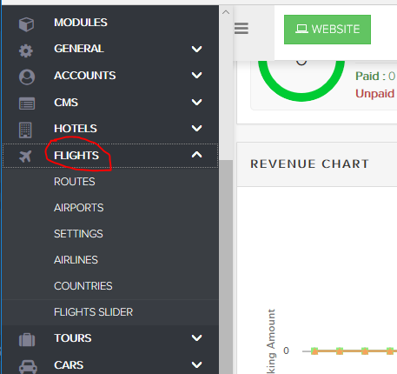

1. **Number**

Capture ‘Total Admins’, ‘Total Customers‘, and ‘Total Bookings’ number

‘Total Admins’ //*[contains(text(),' Total Admins ')]/b

‘Total Customers‘ //*[contains(text(),'Total Customers ')]/b

‘Total Bookings’ //*[contains(text(),' Total Bookings')]/b

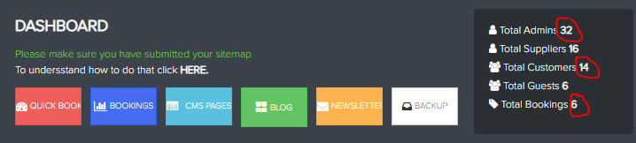

1. **Icon**

Capture ‘Hotels’, ‘Flights‘, ‘Tours’ and ‘Cars’ icon

‘Hotels’ //*[name()='text' and contains(text(),'Hotels')]

‘Flights‘ //*[name()='text' and contains(text(),'Flights')]

‘Tours’ //*[name()='text' and contains(text(),'Tours')]

‘Cars’ //*[name()='text' and contains(text(),'Cars')]

## 

1. **List Cells**

Capture list Cells ‘Ref No’ that ID number is greater than 3

//td[4][string-length(text())>3

## 

1. **Checkbox Cell**

Capture Checkbox Cell that Status is ‘PAID’

//span[text()='Paid']//parent::td/preceding-sibling::td//ins

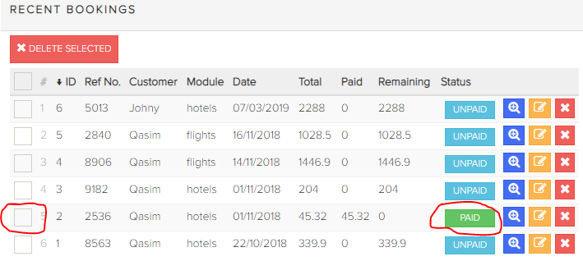

1. **Icon on Cell**

Capture Delete icon on Cell that ‘Ref No’ is ‘8906’

//td[4][text()='8906']/following-sibling::td//i[@class='fa fa-times']

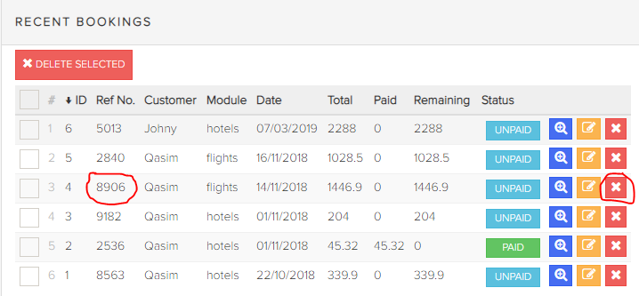

1. **Label on Cell**

Capture Label on ‘Paid’ column that Number is not 0

//*[@id="content"]//tr[5]/td[9][text()>0]

//*[@id="content"]//tr[5]/td[count(//th[contains(text(), 'Paid')]/preceding-sibling::th) + 1][text()>0]

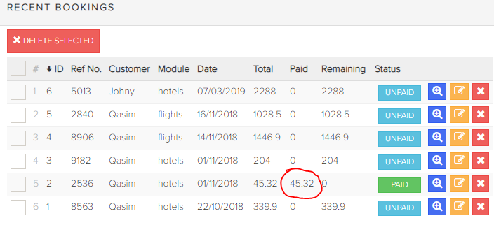

1. **Link on Cell**

Select HOTELS/HOTELS menu bar

Capture 'Rendezvous Hotels' hotel is 2 Starts

//td[./a[contains(text(),'Rendezvous Hotels')]]/following-sibling::td[count(i[@class='star fa fa-star'])=2]

Capture ‘Hyatt Regency Perth' hotel is 3 Start

//td[a[contains(text(),'Hyatt Regency Perth')]]/following-sibling::td[count(i[@class='star fa fa-star'])=3]

Capture list Hotel names that Start is 3

//td[count(i[@class='star fa fa-star'])=3]/preceding-sibling::td/a

